实验4-H3C交换机VLAN配置和报文分析

课程名称：计算机网络 实验教学学时：4学时

年级/班级： 学生人数： 专业：软件工程

一、实验目的：

（1）掌握交换机VLAN和VLAN端口的配置方法，掌握基于端口划分的VLAN配置方法。
（2）理解路由表和转发表各个表项的含义，以及路由表和转发表的生成过程。
（3）加深对实验3 DHCP、DHCP中继工作机制和配置方法的理解。
（4）掌握Wireshark网络数据分析工具的使用方法，能够根据抓取的数据并结合相应协议的报文格式分析报文中各个字段的含义。

二、实验原理或预习内容

（1）教材涉及路由器和交换机原理的相关章节
（2）H3C MSR 系列路由器和交换机 配置指导(V7)

三、实验环境

（1）硬件环境需求

2台H3S S3600V2交换机，2台H3C MSR 26-30路由器，多台PC 以及console电缆及转接器，若干条双绞线跳线

（2）软件环境需求
Windows 系统平台, Wireshark 软件

四、实验内容

任务概述

主要工作 | 参考资料
配置路由器为DHCP服务器、中继 | 06-三层技术-IP业务配置指导-整本手册  ARP协议：P13  DHCP服务器：P40  DHCP中继：P64
配置静态路由 | 07-三层技术-IP路由配置指导-整本手册  静态路由：P17
配置VLAN | 20131130-H3C S3600V2系列以太网交换机 命令参考-Release 2108-6W100->03-二层技术-以太网交换命令参考->09-VLAN命令->1 VLAN配置命令->1.2 基于端口的VLAN配置命令
路由表(RIB)、转发表(FIB)  RIB Routing Information Base  FIB Forwarding Information Base | 07-三层技术-IP路由配置指导-整本手册,01-IP路由基础 P7  06-三层技术-IP业务配置指导-整本手册,06-IP转发基础P183

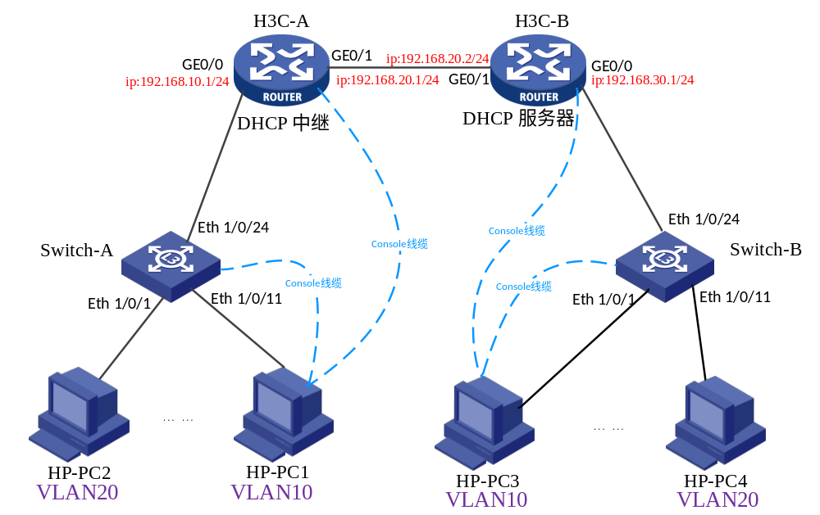

任务一：配置H3C-B路由器为DHCP服务器 、H3C-A路由器为DHCP中继
- Step1：按照网络拓扑结构进行连接
- Step2：开启wireshark，开始抓取网络数据包
Wireshark可以自动检测到当前的可以使用的网卡，如图选择Start进入即可。
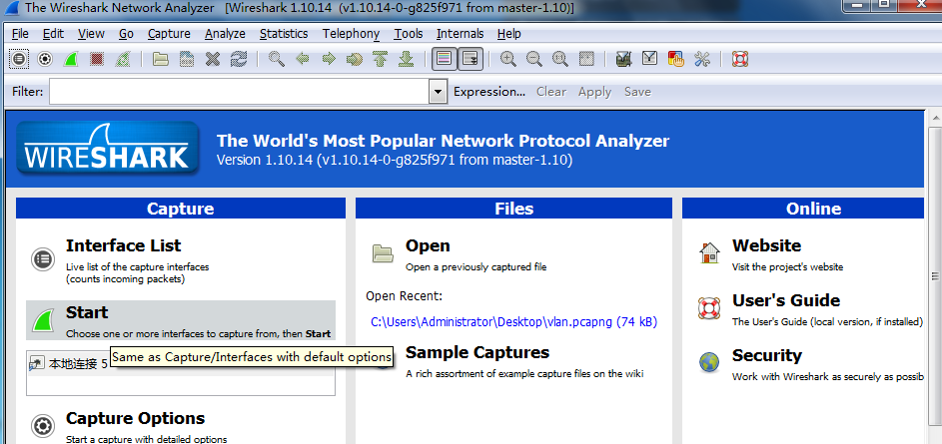
- Step3：配置H3C-B路由器为DHCP服务器
#配置H3C-B路由器为DHCP服务器，配置方法与实验四中的相同
<H3C-B>system-view
System View: return to User View with Ctrl+Z.
[H3C-B]dhcp enable
[H3C-B]dhcp server ip-pool 101
[H3C-B-dhcp-pool-101]network 192.168.10.0 mask 255.255.255.0
[H3C-B-dhcp-pool-101]gateway-list 192.168.10.1
[H3C-B-dhcp-pool-101]dns-list 192.168.10.1
[H3C-B-dhcp-pool-101]quit
[H3C-B]dhcp server ip-pool 102
[H3C-B-dhcp-pool-102]network 192.168.30.0 mask 255.255.255.0
[H3C-B-dhcp-pool-102]gateway-list 192.168.30.1
[H3C-B-dhcp-pool-102]dns-list 192.168.30.1
[H3C-B-dhcp-pool-102]quit
[H3C-B]dhcp server forbidden-ip 192.168.10.1
[H3C-B]dhcp server forbidden-ip 192.168.30.1
[H3C-B]interface GigabitEthernet 0/0
[H3C-B-GigabitEthernet0/0]undo shutdown
[H3C-B-GigabitEthernet0/0]ip address 192.168.30.1 24
#网络拓扑结构 中192.168.30.0子网申请到ip地址
[H3C-B-GigabitEthernet0/0]%Jun 6 12:35:41:881 2015 H3C-B DHCPS/5/ALLOCATE_IP: Server IP = 192.168.30.1, DHCP client IP = 192.168.30.2, DHCP client hardware address = 0015-170b-edfe, DHCP client lease = 86400 seconds.
%Jun 6 12:35:42:381 2015 H3C-B DHCPS/5/ALLOCATE_IP: Server IP = 192.168.30.1, DHCP client IP = 192.168.30.3, DHCP client hardware address = 70f9-6d90-ff91, DHCP client lease = 86400 seconds.
%Jun 6 12:35:42:482 2015 H3C-B DHCPS/5/ALLOCATE_IP: Server IP = 192.168.30.1, DHCP client IP = 192.168.30.4, DHCP client hardware address = 0015-174b-7bea, DHCP client lease = 86400 seconds.
#设置GE0/0 GE0/1
[H3C-B-GigabitEthernet0/0]quit
[H3C-B]interface GigabitEthernet 0/1
[H3C-B-GigabitEthernet0/1]undo shutdown
[H3C-B-GigabitEthernet0/1]ip address 192.168.20.2 24
[H3C-B-GigabitEthernet0/1]dhcp select server
[H3C-B-GigabitEthernet0/1]quit

#增加经由192.168.20.1作为下一跳目的地址为192.168.10.1的静态路由，#192.168.10.0子网申请到ip地址的关键步骤
[H3C-B]ip route-static 192.168.10.1 24 192.168.20.1

#网络拓扑结构中 192.168.10.0子网申请到ip地址
[H3C-B]%Jun 6 12:42:26:671 2015 H3C-B IFNET/3/PHY_UPDOWN: GigabitEthernet0/1 link status is up.
%Jun 6 12:42:26:672 2015 H3C-B IFNET/5/LINK_UPDOWN: Line protocol on the interface GigabitEthernet0/1 is up.
%Jun 6 12:42:42:082 2015 H3C-B DHCPS/5/ALLOCATE_IP: Server IP = 192.168.20.2, DHCP client IP = 192.168.10.2, DHCP client hardware address = 0015-17b2-3765, DHCP client lease = 86400 seconds.
%Jun 6 12:43:03:582 2015 H3C-B DHCPS/5/ALLOCATE_IP: Server IP = 192.168.20.2, DHCP client IP = 192.168.10.3, DHCP client hardware address = 70f9-6d91-03c9, DHCP client lease = 86400 seconds.
%Jun 6 12:43:03:782 2015 H3C-B DHCPS/5/ALLOCATE_IP: Server IP = 192.168.20.2, DHCP client IP = 192.168.10.4, DHCP client hardware address = 0015-175d-3a98, DHCP client lease = 86400 seconds.
#查看路由表、查看转发表
[H3C-B]display ip routing-table

Destinations : 17 Routes : 17

Destination/Mask Proto Pre Cost NextHop Interface
0.0.0.0/32 Direct 0 0 127.0.0.1 InLoop0
127.0.0.0/8 Direct 0 0 127.0.0.1 InLoop0
127.0.0.0/32 Direct 0 0 127.0.0.1 InLoop0
127.0.0.1/32 Direct 0 0 127.0.0.1 InLoop0
127.255.255.255/32 Direct 0 0 127.0.0.1 InLoop0
192.168.10.0/24 Static 60 0 192.168.20.1 GE0/1
192.168.20.0/24 Direct 0 0 192.168.20.2 GE0/1
192.168.20.0/32 Direct 0 0 192.168.20.2 GE0/1
192.168.20.2/32 Direct 0 0 127.0.0.1 InLoop0
192.168.20.255/32 Direct 0 0 192.168.20.2 GE0/1
192.168.30.0/24 Direct 0 0 192.168.30.1 GE0/0
192.168.30.0/32 Direct 0 0 192.168.30.1 GE0/0
192.168.30.1/32 Direct 0 0 127.0.0.1 InLoop0
192.168.30.255/32 Direct 0 0 192.168.30.1 GE0/0
224.0.0.0/4 Direct 0 0 0.0.0.0 NULL0
224.0.0.0/24 Direct 0 0 0.0.0.0 NULL0
255.255.255.255/32 Direct 0 0 127.0.0.1 InLoop0

[H3C-B]display fib
…………………(省略显示内容)
#查看ARP表项，结合ARP协议分析，并将各个设备的物理地址和IP对应起来
[H3C-B]display arp all
Type: S-Static D-Dynamic M-Multiport I-Invalid
IP address MAC address VLAN Interface Aging Type
192.168.30.2 0015-170b-edfe N/A GE0/0 19 D
192.168.30.3 70f9-6d90-ff91 N/A GE0/0 10 D
192.168.30.4 0015-174b-7bea N/A GE0/0 20 D
192.168.20.1 70f9-6d6e-793c N/A GE0/1 17 D
[H3C-B]
- Step4：配置H3C-A路由器为DHCP中继
#此处的H3C-A路由器配置与实验四中的配置一样，具体如下
<H3C-A>system-view
System View: return to User View with Ctrl+Z.
[H3C-A]dhcp enable
[H3C-A]interface GigabitEthernet 0/0
[H3C-A-GigabitEthernet0/0]undo shutdown
[H3C-A-GigabitEthernet0/0]ip address 192.168.10.1 24
#GE0/0设置为DHCP中继,并设置DHCP 服务器地址
[H3C-A-GigabitEthernet0/0]dhcp select relay
[H3C-A-GigabitEthernet0/0]dhcp relay server-address 192.168.20.2
[H3C-A-GigabitEthernet0/0]quit
[H3C-A]interface GigabitEthernet 0/1
[H3C-A-GigabitEthernet0/1]undo shutdown
[H3C-A-GigabitEthernet0/1]ip address 192.168.20.1 24
[H3C-A-GigabitEthernet0/1]quit
#增加经由192.168.20.2作为吓一跳目的地址为192.168.30.1的静态路由
[H3C-A]ip route-static 192.168.30.1 24 192.168.20.2 [H3C-A]display arp all
Type: S-Static D-Dynamic M-Multiport I-Invalid
IP address MAC address VLAN Interface Aging Type
192.168.20.2 70f9-6d70-1f05 N/A GE0/1 17 D
192.168.10.2 0015-17b2-3765 N/A GE0/0 20 D
192.168.10.3 70f9-6d91-03c9 N/A GE0/0 18 D
192.168.10.4 0015-175d-3a98 N/A GE0/0 20 D
#查看H3C-A路由器的路由表
[H3C-A]display ip routing-table

Destinations : 17 Routes : 17

Destination/Mask Proto Pre Cost NextHop Interface
0.0.0.0/32 Direct 0 0 127.0.0.1 InLoop0
127.0.0.0/8 Direct 0 0 127.0.0.1 InLoop0
127.0.0.0/32 Direct 0 0 127.0.0.1 InLoop0
127.0.0.1/32 Direct 0 0 127.0.0.1 InLoop0
127.255.255.255/32 Direct 0 0 127.0.0.1 InLoop0
192.168.10.0/24 Direct 0 0 192.168.10.1 GE0/0
192.168.10.0/32 Direct 0 0 192.168.10.1 GE0/0
192.168.10.1/32 Direct 0 0 127.0.0.1 InLoop0
192.168.10.255/32 Direct 0 0 192.168.10.1 GE0/0
192.168.20.0/24 Direct 0 0 192.168.20.1 GE0/1
192.168.20.0/32 Direct 0 0 192.168.20.1 GE0/1
192.168.20.1/32 Direct 0 0 127.0.0.1 InLoop0
192.168.20.255/32 Direct 0 0 192.168.20.1 GE0/1
192.168.30.0/24 Static 60 0 192.168.20.2 GE0/1
224.0.0.0/4 Direct 0 0 0.0.0.0 NULL0
224.0.0.0/24 Direct 0 0 0.0.0.0 NULL0
255.255.255.255/32 Direct 0 0 127.0.0.1 InLoop0
#查看H3C-A路由器的转发表，
#请结合参考资料自主分析路由表和转发表表项的含义，以及两者的区别与联系
[H3C-A]display fib

Destination count: 21 FIB entry count: 21

Flag:
U:Useable G:Gateway H:Host B:Blackhole D:Dynamic S:Static
R:Relay F:FRR

Destination/Mask Nexthop Flag OutInterface/Token Label
0.0.0.0/32 127.0.0.1 UH InLoop0 Null
127.0.0.0/8 127.0.0.1 U InLoop0 Null
127.0.0.0/32 127.0.0.1 UH InLoop0 Null
127.0.0.1/32 127.0.0.1 UH InLoop0 Null
127.255.255.255/32 127.0.0.1 UH InLoop0 Null
192.168.10.0/24 192.168.10.1 U GE0/0 Null
192.168.10.0/32 192.168.10.1 UBH GE0/0 Null
192.168.10.1/32 127.0.0.1 UH InLoop0 Null
192.168.10.2/32 192.168.10.2 UH GE0/0 Null
192.168.10.3/32 192.168.10.3 UH GE0/0 Null
192.168.10.4/32 192.168.10.4 UH GE0/0 Null
192.168.10.255/32 192.168.10.1 UBH GE0/0 Null
192.168.20.0/24 192.168.20.1 U GE0/1 Null
192.168.20.0/32 192.168.20.1 UBH GE0/1 Null
192.168.20.1/32 127.0.0.1 UH InLoop0 Null
192.168.20.2/32 192.168.20.2 UH GE0/1 Null
192.168.20.255/32 192.168.20.1 UBH GE0/1 Null
192.168.30.0/24 192.168.20.2 USGR GE0/1 Null
224.0.0.0/4 0.0.0.0 UB NULL0 Null
224.0.0.0/24 0.0.0.0 UB NULL0 Null
255.255.255.255/32 127.0.0.1 UH InLoop0 Null

#待192.168.10.0子网的设备获得了ip地址之后，在H3C-B路由器中查看当前正在使用的ip地址
[H3C-B]display dhcp server ip-in-use
IP address Client identifier/ Lease expiration Type
Hardware address
192.168.10.2 0100-1517-b237-65 Jun 7 18:05:58 2015 Auto(C)
192.168.10.3 0170-f96d-9103-c9 Jun 7 18:04:18 2015 Auto(C)
192.168.10.4 0100-1517-5d3a-98 Jun 7 18:06:17 2015 Auto(C)
192.168.30.2 0100-1517-0bed-fe Jun 7 18:00:06 2015 Auto(C)
192.168.30.3 0170-f96d-90ff-91 Jun 7 18:00:07 2015 Auto(C)
192.168.30.4 0100-1517-4b7b-ea Jun 7 18:00:07 2015 Auto(C)
就可以得到以下的设备数据。构造此表对于测试连通性提供了方便。
设备名称 | IP地址 | MAC 地址 | 网关/DNS | 接口
HP-PC1 | 192.168.10.4 | 0015-175d-3a98 | 192.168.10.1 | Switch-A E 1/0/1
HP-PC2 | 192.168.10.2 | 0015-17b2-3765 | 192.168.10.1 | Switch-A E 1/0/11
HP-PC3 | 192.168.30.2 | 0015-170b-edfe | 192.168.30.1 | Switch-B E 1/0/1
HP-PC4 | 192.168.30.4 | 0015-174b-7bea | 192.168.30.1 | Switch-B E 1/0/11

#测试HP-PC1与HP-PC3、HP-PC4的连通性，发现均可以通信
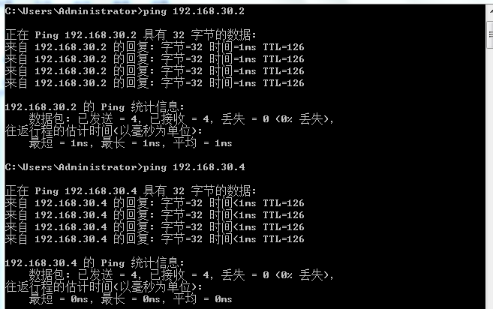

任务二：配置基于端口划分的VLAN
- Step1：配置Switch-A和Switch-B交换机
#将console线缆对应网络拓扑结构连接到交换机，即HP-PC1连接Switch-A，HP-PC2连接Switch-B
[H3C-A]
#从console连接成功
<Switch-A>
#Jan 1 00:14:09:388 2010 Switch-A SHELL/4/LOGIN:
Trap 1.3.6.1.4.1.25506.2.2.1.1.3.0.1<hh3cLogIn>: login from Console
<Switch-A>
%Jan 1 00:14:09:539 2010 Switch-A SHELL/5/SHELL_LOGIN: Console logged in from aux0.
<Switch-A>system-view
System View: return to User View with Ctrl+Z.
#查看当前交换机的接口
[Switch-A]display interface brief
The brief information of interface(s) under route mode:
Link: ADM - administratively down; Stby - standby
Protocol: (s) - spoofing
Interface Link Protocol Main IP Description
NULL0 UP UP(s) --
Vlan1 UP UP 192.168.10.3
The brief information of interface(s) under bridge mode:
Link: ADM - administratively down; Stby - standby
Speed or Duplex: (a)/A - auto; H - half; F - full
Type: A - access; T - trunk; H - hybrid
Interface Link Speed Duplex Type PVID Description
Eth1/0/1 UP 100M(a) F(a) A 1
Eth1/0/2 DOWN auto A A 1
…………………
Eth1/0/10 DOWN auto A A 1
Eth1/0/11 UP 100M(a) F(a) A 1
Eth1/0/12 DOWN auto A A 1
…………………
Eth1/0/23 DOWN auto A A 1
Eth1/0/24 UP 100M(a) F(a) A 1
GE1/0/25 DOWN auto A A 1
GE1/0/26 DOWN auto A A 1
GE1/0/27 DOWN auto A A 1
GE1/0/28 DOWN auto A A 1
#查看当前所有的VLAN，发现存在默认的VLAN 0001，同时注意以太网端口名字的格式 Ethernet1/0/1…
[Switch-A]display vlan all
VLAN ID: 1
VLAN Type: static
Route Interface: configured
IPv4 address: 192.168.10.3
IPv4 subnet mask: 255.255.255.0
Description: VLAN 0001
Name: VLAN 0001
Tagged Ports: none
Untagged Ports:
Ethernet1/0/1 Ethernet1/0/2 Ethernet1/0/3
…………………
Ethernet1/0/22 Ethernet1/0/23 Ethernet1/0/24
GigabitEthernet1/0/25 GigabitEthernet1/0/26 GigabitEthernet1/0/27
GigabitEthernet1/0/28
#创建名称为10的vlan
[Switch-A]vlan 10
#指定VLAN 做包括的端口
[Switch-A-vlan10]port Ethernet 1/0/1 to Ethernet 1/0/10
[Switch-A-vlan10]vlan 20
#创建名称为20的vlan
[Switch-A-vlan20]port Ethernet 1/0/11 to Ethernet 1/0/20
[Switch-A-vlan20]quit
#查看配置之后的vlan
[Switch-A]display vlan all
VLAN ID: 1
VLAN Type: static
Route Interface: configured
IPv4 address: 192.168.10.2
IPv4 subnet mask: 255.255.255.0
Description: VLAN 0001
Name: VLAN 0001
Tagged Ports: none
Untagged Ports:
Ethernet1/0/21 Ethernet1/0/22 Ethernet1/0/23
Ethernet1/0/24
GigabitEthernet1/0/25 GigabitEthernet1/0/26 GigabitEthernet1/0/27
GigabitEthernet1/0/28

VLAN ID: 10
VLAN Type: static
Route Interface: not configured
Description: VLAN 0010
Name: VLAN 0010
Tagged Ports: none
Untagged Ports:
Ethernet1/0/1 Ethernet1/0/2 Ethernet1/0/3
Ethernet1/0/4 Ethernet1/0/5 Ethernet1/0/6
Ethernet1/0/7 Ethernet1/0/8 Ethernet1/0/9
Ethernet1/0/10

VLAN ID: 20
VLAN Type: static
Route Interface: not configured
Description: VLAN 0020
Name: VLAN 0020
Tagged Ports: none
Untagged Ports:
Ethernet1/0/11 Ethernet1/0/12 Ethernet1/0/13
Ethernet1/0/14 Ethernet1/0/15 Ethernet1/0/16
Ethernet1/0/17 Ethernet1/0/18 Ethernet1/0/19
Ethernet1/0/20

# HP-PC2连接Switch-B，将以上的配置在H3C-B交换机上进行同样的配置
<Switch-B>
#Jan 1 00:16:51:943 2010 Switch-B SHELL/4/LOGIN:
Trap 1.3.6.1.4.1.25506.2.2.1.1.3.0.1<hh3cLogIn>: login from Console
%Jan 1 00:16:52:094 2010 Switch-B SHELL/5/SHELL_LOGIN: Console logged in from aux0.
<Switch-B>system-view
System View: return to User View with Ctrl+Z.
[Switch-B]display interface brief
…………………(省略显示内容)
[Switch-B]vlan 10
[Switch-B-vlan10]port Ethernet 1/0/1 to Ethernet 1/0/20
[Switch-B-vlan10]vlan 20
[Switch-B-vlan20]port Ethernet 1/0/11 to Ethernet 1/0/20
[Switch-B-vlan20]quit
#查看配置之后的vlan
[Switch-B]display vlan all
…………………(省略显示内容)
#测试HP-PC1与HP-PC3、HP-PC4的连通性，发现均不能通信
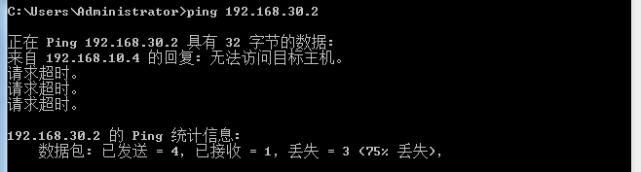

#结合端口的三种链路类型的报文处理方式，尝试分析其中的原因

- Step2：配置Trunk链路类型端口
[Switch-A]interface Ethernet 1/0/1
#port link-type { access | hybrid | trunk }该命令用来设置端口的链路类型
[Switch-A-Ethernet1/0/1]port link-type trunk
#port trunk permit vlan { vlan-list | all }
#该命令用来允许指定的VLAN通过当前Trunk端口
[Switch-A-Ethernet1/0/1]port trunk permit vlan 10
Please wait... Done.
[Switch-A-Ethernet1/0/1]display interface Ethernet 1/0/1
Ethernet1/0/1 current state: UP
IP Packet Frame Type: PKTFMT_ETHNT_2, Hardware Address: 70f9-6d91-03e8
Description: Ethernet1/0/1 Interface
Loopback is not set
…………………(省略显示内容)
PVID: 1
Mdi type: auto
Port link-type: trunk
VLAN passing : 1(default vlan), 10
VLAN permitted: 1(default vlan), 10
Trunk port encapsulation: IEEE 802.1q
Port priority: 0
………..(省略其他信息)
[Switch-A-Ethernet1/0/1]quit
[Switch-A]interface Ethernet 1/0/11
[Switch-A-Ethernet1/0/11]port link-type trunk
[Switch-A-Ethernet1/0/11]port trunk permit vlan 20
Please wait... Done.
[Switch-A-Ethernet1/0/11]display interface Ethernet 1/0/11
Ethernet1/0/11 current state: UP
IP Packet Frame Type: PKTFMT_ETHNT_2, Hardware Address: 70f9-6d91-03f2
Description: Ethernet1/0/11 Interface
Loopback is not set
…………………(省略显示内容)
PVID: 1
Mdi type: auto
Port link-type: trunk
VLAN passing : 1(default vlan), 20
VLAN permitted: 1(default vlan), 20
Trunk port encapsulation: IEEE 802.1q
Port priority: 0
………..(省略其他信息)
[Switch-A-Ethernet1/0/11]quit
#display port { hybrid | trunk }，显示设备上当前存在的Hybrid或Trunk端口
[Switch-A]display port trunk
Interface PVID VLAN passing
Eth1/0/1 1 1, 10,
Eth1/0/11 1 1, 20,
#将以上的配置在H3C-B交换机上进行同样的配置，
[Switch-B]interface Ethernet 1/0/1
[Switch-B-Ethernet1/0/1]port link-type trunk
[Switch-B-Ethernet1/0/1]port trunk permit vlan 10
Please wait... Done.
[Switch-B-Ethernet1/0/1]display interface Ethernet 1/0/1
…………………(省略显示内容)
[Switch-B-Ethernet1/0/1]interface Ethernet 1/0/11
[Switch-B-Ethernet1/0/11]port link-type trunk
[Switch-B-Ethernet1/0/11]port trunk permit vlan 20
Please wait... Done.
[Switch-B-Ethernet1/0/11]display interface Ethernet 1/0/11
…………………(省略显示内容)
[Switch-B-Ethernet1/0/11]quit
#查看trunk端口
[Switch-B]display port trunk
……………..(省略其他信息)
#测试HP-PC1与HP-PC3、HP-PC4的连通性，发现均能通信
#尝试分析此时交换机对来自vlan10 和vlan20 的报文的处理方式
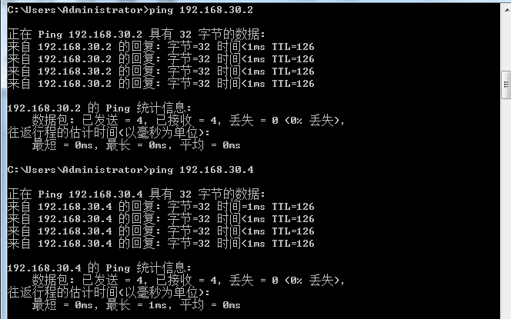

- Step3：配置Hybrid链路类型端口
[Switch-A]interface Ethernet 1/0/1
#在接口视图下，端口的链路类型不能从trunk直接转化成hybrid，
#必须首先转化成access类型，在进行转化
[Switch-A-Ethernet1/0/1]port link-type hybrid
Because it is a Trunk-port, Hybrid can not be specified, please set it Access first.
[Switch-A-Ethernet1/0/1]port link-type access
Please wait........................................... Done.
[Switch-A-Ethernet1/0/1]port link-type hybrid
[Switch-A-Ethernet1/0/1]port hybrid vlan 10 20 tagged
Please wait... Done.
[Switch-A-Ethernet1/0/1]display interface Ethernet 1/0/1
Ethernet1/0/1 current state: UP
IP Packet Frame Type: PKTFMT_ETHNT_2, Hardware Address: 70f9-6d91-03e8
Description: Ethernet1/0/1 Interface
Loopback is not set
…………………(省略显示内容)
PVID: 1
Mdi type: auto
Port link-type: hybrid
Tagged VLAN ID : 10, 20
Untagged VLAN ID : 1
Port priority: 0
…………………(省略显示内容)
[Switch-A-Ethernet1/0/1]interface Ethernet 1/0/11
[Switch-A-Ethernet1/0/11]port link-type access
Please wait........................................... Done.
[Switch-A-Ethernet1/0/11]port link-type hybrid
[Switch-A-Ethernet1/0/11]port hybrid vlan 10 20 tagged
Please wait... Done.
[Switch-A-Ethernet1/0/11]display interface Ethernet 1/0/11
Ethernet1/0/11 current state: UP
IP Packet Frame Type: PKTFMT_ETHNT_2, Hardware Address: 70f9-6d91-03f2
Description: Ethernet1/0/11 Interface
Loopback is not set
…………………(省略显示内容)
PVID: 1
Mdi type: auto
Port link-type: hybrid
Tagged VLAN ID : 10, 20
Untagged VLAN ID : 1
Port priority: 0
…………………(省略显示内容)
[Switch-A-Ethernet1/0/11]quit
[Switch-A]display mac-address
MAC ADDR VLAN ID STATE PORT INDEX AGING TIME(s)
0015-175d-3a98 1 Learned Ethernet1/0/1 AGING
0015-17b2-3765 1 Learned Ethernet1/0/11 AGING
70f9-6d6e-793b 1 Learned Ethernet1/0/24 AGING

--- 3 mac address(es) found ---
#查看路由表
[Switch-A]display ip routing-table
Routing Tables: Public
Destinations : 5 Routes : 5

Destination/Mask Proto Pre Cost NextHop Interface

0.0.0.0/0 Static 70 0 192.168.10.1 Vlan1
127.0.0.0/8 Direct 0 0 127.0.0.1 InLoop0
127.0.0.1/32 Direct 0 0 127.0.0.1 InLoop0
192.168.10.0/24 Direct 0 0 192.168.10.3 Vlan1
192.168.10.3/32 Direct 0 0 127.0.0.1 InLoop0
#查看转发表
[Switch-A]display fib
Destination count: 5 FIB entry count: 5

Flag:
U:Useable G:Gateway H:Host B:Blackhole D:Dynamic S:Static
R:Relay

Destination/Mask Nexthop Flag OutInterface InnerLabel Token
0.0.0.0/0 192.168.10.1 USG Vlan1 Null Invalid
192.168.10.0/24 0.0.0.0 U Vlan1 Null Invalid
192.168.10.3/32 127.0.0.1 UH InLoop0 Null Invalid
127.0.0.1/32 127.0.0.1 UH InLoop0 Null Invalid
127.0.0.0/8 127.0.0.1 U InLoop0 Null Invalid
#查看hybrid端口
[Switch-A]display port hybrid
Interface PVID VLAN passing
Eth1/0/1 1 Tagged: 10, 20,
Untagged:1,
Eth1/0/11 1 Tagged: 10, 20,
Untagged:1,
#查看当前vlan
[Switch-A]display vlan all
VLAN ID: 1
VLAN Type: static
Route Interface: configured
IPv4 address: 192.168.10.2
IPv4 subnet mask: 255.255.255.0
Description: VLAN 0001
Name: VLAN 0001
Tagged Ports: none
Untagged Ports:
Ethernet1/0/1 Ethernet1/0/11 Ethernet1/0/21
Ethernet1/0/22 Ethernet1/0/23 Ethernet1/0/24
GigabitEthernet1/0/25 GigabitEthernet1/0/26 GigabitEthernet1/0/27
GigabitEthernet1/0/28

VLAN ID: 10
VLAN Type: static
Route Interface: not configured
Description: VLAN 0010
Name: VLAN 0010
Tagged Ports:
Ethernet1/0/1 Ethernet1/0/11
Untagged Ports:
Ethernet1/0/2 Ethernet1/0/3 Ethernet1/0/4
Ethernet1/0/5 Ethernet1/0/6 Ethernet1/0/7
Ethernet1/0/8 Ethernet1/0/9 Ethernet1/0/10

VLAN ID: 20
VLAN Type: static
Route Interface: not configured
Description: VLAN 0020
Name: VLAN 0020
Tagged Ports:
Ethernet1/0/1 Ethernet1/0/11
Untagged Ports:
Ethernet1/0/12 Ethernet1/0/13 Ethernet1/0/14
Ethernet1/0/15 Ethernet1/0/16 Ethernet1/0/17
Ethernet1/0/18 Ethernet1/0/19 Ethernet1/0/20
#将以上的配置在H3C-B交换机上进行同样的配置，
[Switch-B]interface Ethernet 1/0/1
[Switch-B-Ethernet1/0/1]port link-type access
Please wait........................................... Done.
[Switch-B-Ethernet1/0/1]port link-type hybrid
#查看port hybrid的具体使用方法
[Switch-B-Ethernet1/0/1]port hybrid ?
ip-subnet-vlan Specify current hybrid port's IP subnet-based VLAN
characteristics
protocol-vlan Specify current hybrid port's protocol-based VLAN
characteristics
pvid Specify current Hybrid port's PVID VLAN characteristics
vlan Specify current Hybrid port's VLAN ID
[Switch-B-Ethernet1/0/1]port hybrid vlan 10 20 tagged
Please wait... Done.
[Switch-B-Ethernet1/0/1]display interface Ethernet 1/0/1
…………………(省略显示内容)
[Switch-B-Ethernet1/0/1]interface Ethernet 1/0/11
[Switch-B-Ethernet1/0/11]port link-type access
Please wait........................................... Done.
[Switch-B-Ethernet1/0/11]port link-type hybrid
[Switch-B-Ethernet1/0/11]port hybrid vlan 10 20 tagged
Please wait... Done.
[Switch-B-Ethernet1/0/11]display interface Ethernet 1/0/11
…………………(省略显示内容)
[Switch-B-Ethernet1/0/11]quit
#查看hybrid端口
[Switch-B]display port hybrid
…………………(省略显示内容)
#查看当前vlan
[Switch-B]display vlan all
…………………(省略显示内容)
#测试HP-PC1与HP-PC3、HP-PC4的连通性，发现均能通信
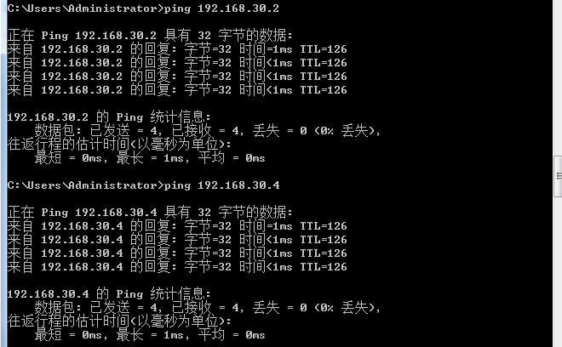
- Step4：停止wireshark，并保存数据
选择红色的按钮，即可停止抓包。
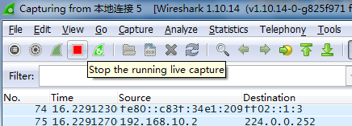
如图选择保存按钮对数据进行保存。默认保存成.pcapng文件格式。
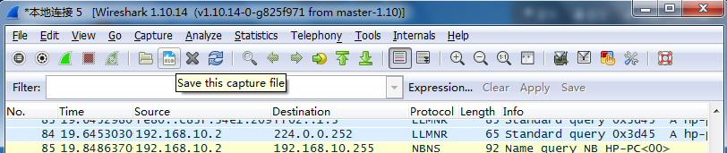
- Step5：对抓取的数据包进行分析
在Filter中输入arp即可过滤出所有arp协议的数据包，选择其中一条，双击即可得到详细的报文分析。如图：
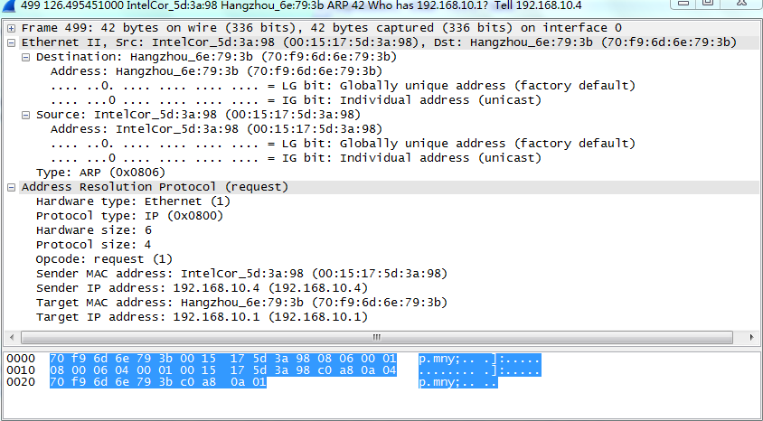
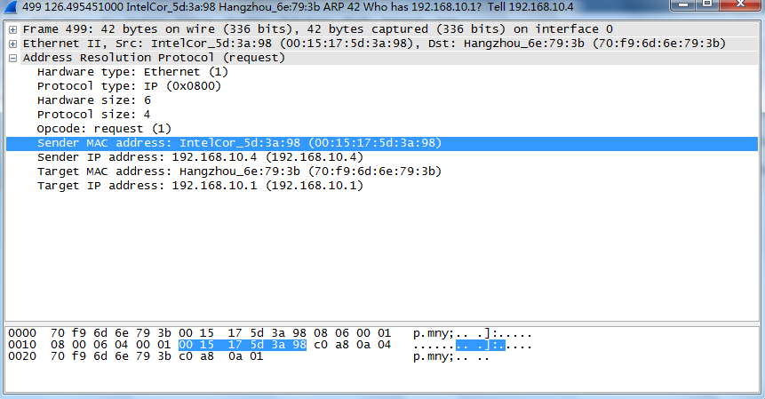

五、实验结论及思考题
1. VLAN如何实现不同逻辑子网间的信息隔离？
在一台未设置任何VLAN的二层交换机上，任何广播帧都会被转发到除接收端口外的所有其他端口，设置VLAN后，VLAN通过限制广播帧转发的范围分割了广播域，在交换机种的维护了一个端口到VLAN的映射表，因此将一台交换机在逻辑上分割成了数台交换机，由VLAN生成的逻辑上的交换机是互不通信的。

